Marysville

Primary School.



Foundation Handbook.

2015

**WELCOME**

Dear Parents,

On behalf of the Marysville Primary School community, I would like to welcome you, your family and your child to our school – our home away from home.

Research highlights the benefits of quality pre school programs. Pre school learning is based on the Early Years Learning and Development Framework. <http://www.education.vic.gov.au/childhood/Pages/default.aspx>

Learning in the Foundation Year is centred on Early Years Literacy and Numeracy strategies which have been developed specifically to advance all children’s learning and development to eight years of age. (‘Key features of whole school design’. Hill and Crevola).

In 2014, all students from Years Foundation to Year 10 are mandated to learn from the National and Victorian Curriculum (AusVELS) for Mathematics, English, Science, History, Humanities and Arts. This exciting initiative will positively challenge the learning of our children and their teachers. Please see <http://ausvels.vcaa.vic.edu.au/>

Marysville Primary prioritises continuous improvement through our Strategic and Annual Plans which focus on literacy, numeracy, student engagement and wellbeing. We aim to provide a safe and supportive learning environment for all students while challenging our students to achieve their academic very best for a life of learning. Powerful learning relies on great teaching practice. We look to content knowledge, teamwork, assessment and evidence to inform teachers, teaching and progress student learning.

Marysville prioritises academic achievement through mandated a daily two hour literacy block incorporating reading, writing, speaking and listening and a daily one hour numeracy block incorporating Number and Measurement. Marysville is committed to Professor John Munro’s (HRLTP) literacy strategies and Waters and Montgomery numeracy research (Leading Numeracy 2007 – the Learner). including the developmental continuum and number fluency.

In addition literacy intervention, the Arts, Music, PMP, Physical Education, Sports, Camping and Skiing, Religion (optional), Buddies, Junior School Council, Gardening Program all value add to our educational outcomes. Engaged, focussed teaching, well structured support sustains students social and emotional wellbeing.

Our community understands the power of a positive attitude and the desire to do more and learn more. We nurture talent through tailored teaching programs allowing children to achieve to their full potential. Your involvement and support is valued and contributes to the successes we all share. We hold true our values: Respect, Responsibility, Honesty and Community. I look forward to working together – the door is open.

Warmest Regards,

## Mr. Leigh Woods.

## Principal.

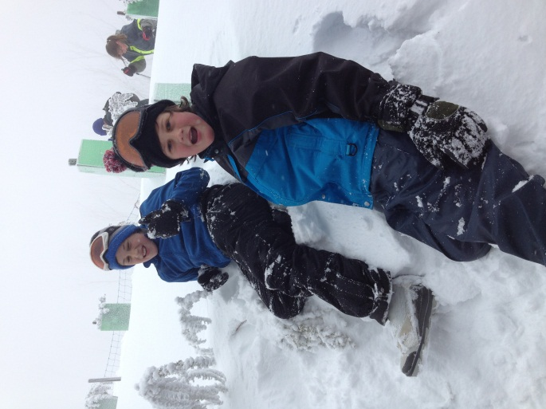

|  |  |  |  |
| --- | --- | --- | --- |
| 2014 TERM DATES | | | |
| **Term 1** | Tuesday 28th January – teachers return  Commencement of Students – Wednesday 29th January | to | Friday 4th April.  Good Friday 18th April.  Easter Monday 21st April  ANZAC Day Friday 25th April. |
| **Term 2** | Monday 22nd April | to | Friday 27th June |
| **Term 3** | Monday 14th July | to | Friday 19th September |
| **Term 4** | Monday 6th October | to | Friday 19th December |

**The staff are on duty for the care of your child between 8.45 a.m. - 3.45 p.m.**

**SCHOOL HOURS:** 9.00 a.m. to 3.30 p.m. - for all grades.

**WET DAYS:** As above.Children remain inside during recess and lunch times.

**EXTREME HEAT DAYS:** As above.Children remain inside during recess and lunch times.

**CODE RED DAYS:**  School closed due to extreme bushfire weather. Parents will be informed by 2pm the previous day if this is to occur.

[](http://www.google.com.au/imgres?q=school+clipart+for+teachers&hl=en&safe=active&biw=1233&bih=941&tbm=isch&tbnid=540hTkqvF2qaBM:&imgrefurl=http://www.clipartpal.com/clipart_pd/education/teacherswormsigns_12176.html&imgurl=http://www.clipartpal.com/_thumbs/pd/education/welcome_blue_2.png&w=376&h=334&ei=Ji88UILzLaT5mAX74YAI&zoom=1&iact=hc&vpx=952&vpy=552&dur=1799&hovh=212&hovw=238&tx=106&ty=109&sig=117378215908878520347&page=2&tbnh=140&tbnw=158&start=35&ndsp=42&ved=1t:429,r:27,s:35,i:266)

SCHOOL PROFILE

**Motto**

Our school motto is **ACE** -“Achieving and Celebrating Excellence”.

**Mission**

At Marysville Primary School we provide all children with powerful learning focussed promoting academic achievement and an environment to support social-emotional well being. We aim to assist students begin their journey through lifelong learning with positive attitude and structured support.

***Marysville Primary School has the following agreed values:***

Community spirit: -To have and foster a sense of belonging and pride in

our school and in the wider community.

-To encourage positive relationships involving parents, families and communities.

-To provide students with an understanding of their place in the local and global community and teach them the value of diversity.

-To share knowledge and resources cooperatively and work together to benefit the wider school community.

Respect: -Build mutual respect; treat others with consideration and

regard.

-Being tolerant and accepting of other people’s differences.

-Recognise that everyone has rights and responsibilities.

-Care for property and the environment.

Responsibility: -Provide a supportive and nurturing environment where students are encouraged to share responsibility for their own learning and behaviour.

-Teach positive social behaviours and problem solving skills.

-To be accountable for one’s own actions.

-Resolve differences in a constructive, non-violent and peaceful way.

Honesty: -Truthfulness and consistency with open communications at all times.

[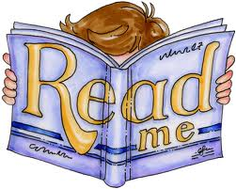](http://www.google.com.au/imgres?q=school+camp+clipart&num=10&hl=en&safe=active&biw=1233&bih=941&tbm=isch&tbnid=-KNle5hoaaRtFM:&imgrefurl=http://www.justrightacademy.org/tag/school/&imgurl=http://www.justrightacademy.org/wp-content/uploads/2010/07/hug-club-clip-art-5911.jpg&w=546&h=437&ei=xSU8UNvyLeHXmAXUsIEg&zoom=1&iact=hc&vpx=253&vpy=276&dur=5185&hovh=201&hovw=251&tx=141&ty=105&sig=117378215908878520347&page=2&tbnh=128&tbnw=160&start=31&ndsp=42&ved=1t:429,r:15,s:31,i:220)-Doing your best: pursue personal excellence in all endeavours.

-Celebrate lifelong learning as an educational community

-Embrace change and considered risk taking***.***

**[](http://www.google.com.au/imgres?start=246&hl=en&biw=1280&bih=652&tbm=isch&tbnid=FLFCp7BqtWNSHM:&imgrefurl=http://www.marysvilletourism.com/marysville-150-years/&docid=sA6s2NViTUKF9M&imgurl=http://www.marysvilletourism.com/wp-content/uploads/150-year-banner.jpg&w=550&h=242&ei=NwlEUrG3K8fqkAXPsoGACw&zoom=1&ved=1t:3588,r:53,s:200,i:163&iact=rc&page=14&tbnh=144&tbnw=328&ndsp=19&tx=236&ty=91)**

**Our History.**

Marysville Primary School was established in 1870.

The fires of February 7th 2009 saw the total destruction of our school and surrounds. Marysville Primary School reopened in April 2010 and is now a 21st Century, state of the art facility with all new spaces and resources. Our grounds may be smaller, but we make full use of the adjoining shire oval, community facility and town park. Marysville is 90 minutes from Melbourne across the magnificent Black Spur. It is located 10 kilometres from the Maroondah Hwy. on the Northern slopes of the Great Dividing range, in close proximity to Lake Eildon, Lake Mountain and the Cathedral State Park.

We have a current enrolment of 44 + students with 3 full time teaching staff, part time specialists and Business Manager. The school operates with three learning groups, a Prep/Year1 class, a 2, 3 and 4 class and a Year 4/ 5 /6 class. Our multi grade structure allows students to progress at individual rates with tailored teaching to meet their needs. The school is an active member of the North East Region Cathedral Cluster of schools.

Small class sizes and individually focused teaching benefits all students.

A feature of the school is its openness and the interaction it has with the community. The parents support and are actively involved in a variety of activities including Perceptual Motor Program, Skiing, Reading, Fundraising and all aspects of the school’s life where their expertise can be utilised. Parents, staff, students and the community regularly work together for mutual benefit, with the school’s Art Exhibition and biannual Fete providing a huge focus.

***Parents are encouraged to be actively involved in all aspects of the school.***

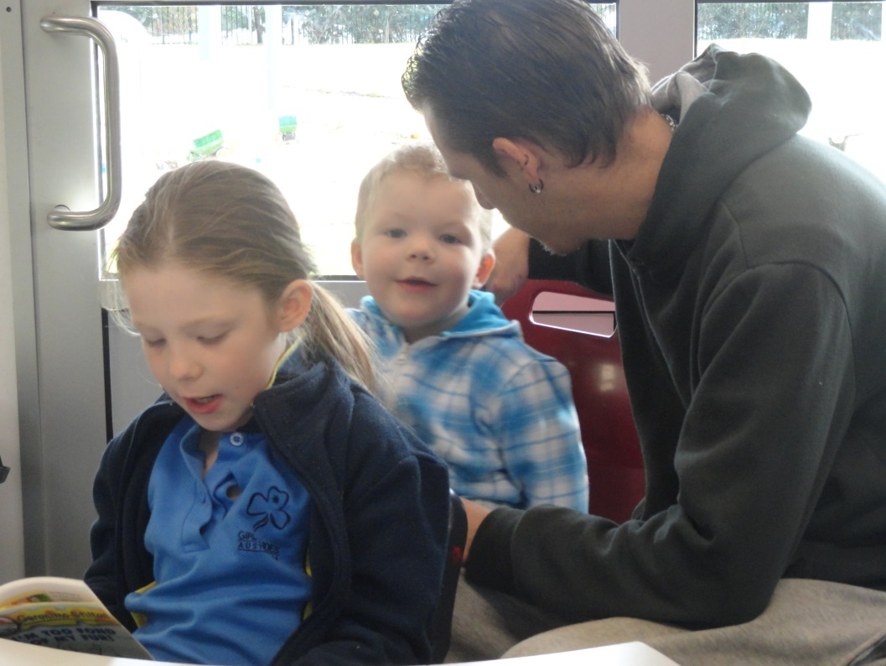

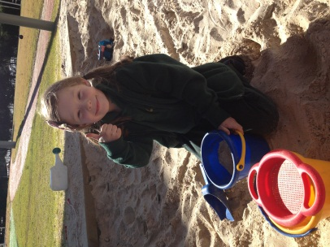

**OVERVIEW – AusVELS CURRICULUM (Foundation to Year 10).**

Our experienced staff provide a comprehensive AusVELS Foundation to Year 6 (and beyond) teaching and learning program while prioritising Literacy and Numeracy.

We hold high expectations of all - true to our values, especially that of mutual respect. Our aim is to teach in depth to develop independent learning. Ourr 21st Century learning spaces and technology rich learning environment directly support your childs education.

**AusVELS ‘Strands’ are:**

1. **Physical, Personal and Social Learning.**

*Students learn about themselves and their place in society. They learn how to stay healthy and active. Students develop skills in building social relationships and working with others. Students develop as independent learners, take responsibility for their learning and develop understanding of rights and responsibilities as local and global citizens.*

1. **Discipline-based Learning** *Students learn the knowledge, skills and behaviours in the arts, English, humanities, mathematics, science and language.*
2. **Interdisciplinary Learning**  *Students explore different ways of thinking, solving problems and communicating. They learn to use a range of technologies to plan, analyse, evaluate and present their work. Students learn about creativity, design principles and processes*

[](http://www.google.com.au/imgres?q=school+clipart+for+teachers&start=201&hl=en&safe=active&biw=1233&bih=941&tbm=isch&tbnid=cLzIFZofyWDq1M:&imgrefurl=http://westford.com/funfest/?page_id=1576&imgurl=http://westford.com/funfest/wp-content/uploads/2011/06/book-clip-art.jpg&w=350&h=325&ei=4i88UK_3BMSKmQW764H4BA&zoom=1&iact=hc&vpx=957&vpy=191&dur=324&hovh=216&hovw=233&tx=197&ty=108&sig=117378215908878520347&page=6&tbnh=133&tbnw=143&ndsp=39&ved=1t:429,r:18,s:201,i:192)

2013 saw the commencement of our teaching and reporting against the AusVels curriculum for English, Mathematics, Science and History.

All students have the opportunity to participate in a range of extra curricular activities including school performances, environmental activities, and interschool sport. Curriculum activities are enhanced through such visits/programs as Waterwatch, Responsible Pet Ownership, Life Education, Swimming Program, ELF day, Rural Schools’ Sports and Camping programs, Sports’ Clinics, Excursions and Performing Arts.

The school has an effective professional development program that focuses on improving student outcomes and best teacher practice whilst incorporating current Department of Education and Early Childhood Development (DEECD) initiatives.

[](http://www.google.com.au/imgres?q=parent+teacher+clipart&start=67&num=10&hl=en&safe=active&biw=1233&bih=941&tbm=isch&tbnid=oOx2a8xuFvcNHM:&imgrefurl=http://lakewindward.pbworks.com/&imgurl=http://lakewindward.pbworks.com/f/a05-01-cartoon-alligator-clipart.jpg&w=564&h=677&ei=lSA8UMvrKe2YmQXtp4CgAg&zoom=1&iact=hc&vpx=118&vpy=118&dur=834&hovh=246&hovw=205&tx=111&ty=117&sig=117378215908878520347&page=3&tbnh=148&tbnw=124&ndsp=40&ved=1t:429,r:20,s:67,i:69)**GENERAL INFORMATION**

SCHOOL HOURS

**9.00am - 11.00am First Session – Literacy Block.**

11.00am - 11.30am Recess

**11.30am - 1.30pm Second Session – Numeracy Block**

1.30pm -2.30pm Lunch

**2.30pm - 3.30pm Third Session**

3.30pm Home Time

***Written notification will be provided if there is any variance of these times.***

SUPERVISION

Please note that the official times of school ground supervision are between 8:45am and 3.45pm. Whilst staff are often available outside these times for administration and preparation purposes, no official responsibility can be taken for children who are in the school grounds out of these hours.

ABSENCES

When your child returns to school after an absence, you are required to supply a note or contact the school in person, giving reasons for the absence. School rolls are legal documents. If possible please notify the school in advance. It is simply not OK to stay away for shopping, being too tired or special occasions such as a birthday. Five days absence a term equates to twenty days a year or almost one whole terms learning in two years. Missing school leaves gaps in your child’s learning.

MEDICAL

**Sick children:**

We have a sick bay which can cater for children who become ill at school. Children should not be sent to school if they are ill and we encourage you to keep them at home. While we recognise work and life pressures please make necessary arrangements for home care should your child be too ill to attend. Please contact your class teacher should you wish to arrange for class work to be sent home.

**Medical records:**

If any of the recorded medical information changes for your child at any time please remember to inform the school office: Phone 59 633256 at your earliest.

Our staff are first aid and anaphylaxis trained.

**Child absences:**

Please inform the school via a written note of reasons for child absences as they must be recorded in attendance rolls.

**Medication while at school:**

To ensure safety and the effective administration of medication, parents must either speak to the teacher or provide signed notification if medication is to be administered at school. **Parents of children with asthma are required to provide full details of recommended treatment in case of attacks** **by supplying an Individual Asthma Management Plan.** Children suffering from asthma must have their puffers/inhalers at school at all times.

[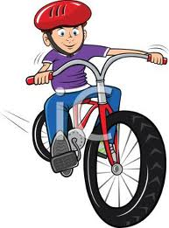](http://www.google.com.au/imgres?q=school+bicycle+clipart&hl=en&safe=active&biw=1233&bih=941&tbm=isch&tbnid=KgRrDrJDL27dJM:&imgrefurl=http://im4ublog.com/summer-is-here/&imgurl=http://im4ublog.com/wp-content/uploads/2012/06/0511-1001-0301-4758_Boy_Riding_a_Bike_Wearing_a_Helmet_clipart_image.jpeg&w=259&h=350&ei=VSo8UMjsOIvnmAXCkIEo&zoom=1&iact=hc&vpx=241&vpy=407&dur=2629&hovh=261&hovw=193&tx=101&ty=115&sig=117378215908878520347&page=2&tbnh=143&tbnw=106&start=35&ndsp=40&ved=1t:429,r:8,s:35,i:207)

BICYCLES

We strongly recommend that your child is familiar with the correct procedures and road rules when riding to and from school. Victorian law stipulates that all cyclists must wear helmets. Bikes are not permitted to be ridden within the school grounds and should be placed in the bike rack during the day. This area is otherwise out of bounds.

NEWSLETTER

**Each Thursday** a school newsletter is published and handed to the eldest child in all families. This provides all the information you need to know about the school on a regular basis and provides an effective means of communication between home and school. Please take the time each week to read the newsletter.

LUNCHES

[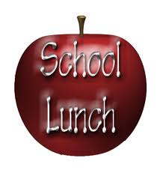](http://www.google.com.au/imgres?q=school+lunch+clipart&hl=en&safe=active&biw=1233&bih=941&tbm=isch&tbnid=wAqXq7P4wJwlxM:&imgrefurl=http://fairhaven.edu/fh/Sickles%20School%20(PK-3)/&imgurl=http://fairhaven.edu/fh/Member's%20Area/Clip%20Art/sicklesprincipal/schoollunch.jpg&w=407&h=432&ei=8Co8UO_jJdGUmQW7oIFg&zoom=1&iact=hc&vpx=581&vpy=146&dur=1444&hovh=231&hovw=218&tx=117&ty=116&sig=117378215908878520347&page=2&tbnh=143&tbnw=125&start=30&ndsp=39&ved=1t:429,r:9,s:30,i:195)Healthy eating habits are strongly encouraged at school and a nutritious breakfast provides a good start to the day. Children eat their lunches under supervision..

We offer students lunch orders one day each week. These are made by a local business and order lists can be opbtained from the office.

INTER SCHOOL SPORT

Our school is involved at various times throughout the year in sporting competitions with local rural schools as part of the Cathedral Cluster of schools. The other schools are Alexandra Primary School, Eildon Primary School, Taggerty Primary School, Buxton Primary School and St. Mary’s Catholic School. These include Athletics, Cross Country and Swimming. A variety of sports are played with the emphasis on enjoyment, participation and sportsmanship.

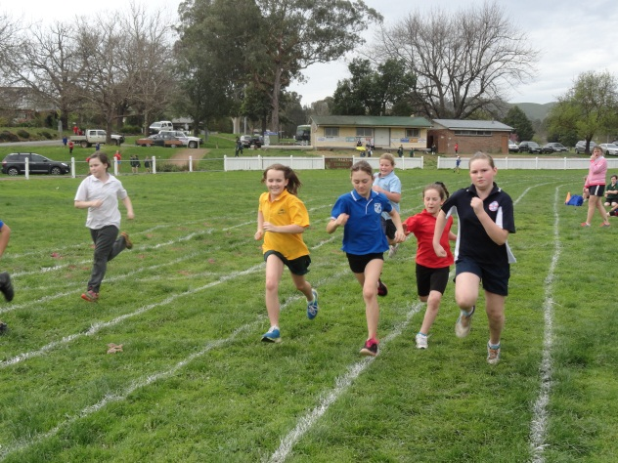

GRADUATION

At the end of the year a special Year 6 graduation evening is held in Marysville. This evening enables us to recognise the achievements of our graduating class. Details are decided annually in consultation with students, staff and School Council.

WORKING BEES

Working bees are organised by the School Council and are held as the need arises to carry out various tasks and to do general tidying up of the school grounds. We strongly encourage your participation.

**SCHOOL REGULATIONS**

UNIFORM

A dress code reinforces in students a pride in their own appearance and instils recognition as an integral part of the school community. At Marysville Primary School it is compulsory to wear school uniform daily. It is also expected on all special occasions and school outings.

Our SunsSmart policy states that broad brimmed, bucket or legionnaire’s hats be worn in Terms 1 and 4.

**Girls’ Summer Uniform**

Green and white check dress or

Green shorts

Gold or green polo T shirt with school logo.

White socks.

Green windcheater with school logo.

School sunsmart hat. (Terms 1 & 4)

Appropriate shoes or sandals. Sandals must have the toe area covered. (No thongs or scuffs)

**[](http://www.google.com.au/imgres?q=school+bag+clipart&start=120&hl=en&safe=active&biw=1233&bih=941&tbm=isch&tbnid=5qsu-2KPdSLe_M:&imgrefurl=http://cutcaster.com/vector/801177282-Cartoon-boy-walking-to-school/&imgurl=http://watermarked.cutcaster.com/cutcaster-vector-801177282-Cartoon-boy-walking-to-school.jpg&w=291&h=450&ei=jCk8ULShGqXZmAW86IDgBA&zoom=1&iact=hc&vpx=1010&vpy=447&dur=3034&hovh=279&hovw=180&tx=102&ty=138&sig=117378215908878520347&page=4&tbnh=147&tbnw=95&ndsp=42&ved=1t:429,r:6,s:120,i:157)Girls’ Winter Uniform**

Green skirt or green track pants.

Green windcheater/jacket with school logo.

Gold or green polo T shirt with school logo or gold or green skivvy.

White socks or navy tights.

Appropriate shoes.

School green beanie

**Boys’ Summer Uniform**

Green shorts

Gold or green polo T shirt with school logo.

White socks.

Green windcheater with school logo.

School sunsmart hat. (Terms 1 & 4)

Appropriate shoes or sandals. (No thongs or scuffs)

**Boys’ Winter Uniform**

Green shorts or track pants.

Gold or green polo T shirt with school logo or gold or green skivvy.

White socks.

Green windcheater/jacket with school logo.

Black shoes or sandals. (No thongs or scuffs)

School green beanie.

***Each year the Year 6 students are offered a special Year 6 rugby top. This is specially printed each year for the students in that class with their names and that of their teacher.***

JEWELLERY

For obvious reasons jewellery is not permitted. Students with pierced ears should take particular care and should only wear studs. Dangling varieties are not permitted.

HAIR

Neat, respectable hair styles are encouraged at all times. Students with long hair should have it tied back in a pony tail, pigtails or plaits and are encouraged to wear ribbons or hair ties in school colours, especially on special occasions. Please be mindful of prevention and treatment (if required) of headlice. Unusual hair styles such as Mohawks and coloured hair is not permitted with the exception of any “Bad Hair Day” style of fundraising.

SCHOOL POLICIES

Written policy statements are prepared by the School Council on a variety of subjects and are updated on a regular basis. These provide direction for the school’s operation and whilst under the jurisdiction of the School Council, input and suggestions are welcomed from everyone.

STUDENT WELFARE SERVICES

A limited number of confidential specialist Social, Speech and specialist services are available to children upon request from parents or teachers and after referral from the school. These include visiting teacher services for the deaf, visually impaired, gifted children and support for students with speech, social or emotional or educational needs. Parent permsiion is required for the delivery of all such specialist assistance and parents will be fully consulted.

HOMEWORK

Homework benefits students by complementing classroom learning, fostering good study habits and providing an opportunity for students to be responsible for their own learning. In the Early Years homework consists mainly of reading activities to, with and by parents whilst in the older rooms independent reading on a daily basis is a standard expectation as well as tasks that provide a continuation of classroom work.

# FUNDRAISING

Fundraising is carried out in conjunction with the Parents’ & Friends Club, Junior School Council, School Council and staff and provides a vital contribution to our school needs. Many major items have been bought with their financial assistance. You are very welcome to become a member of our Parent’s and Friends or School Council groups. Please see one of the staff for contact names and details.

DISCIPLINE

Discipline is a normal part of a child’s development and we promote self discipline as the ideal. Positive reinforcement of good behaviour and encouragement to do the right thing is the school’s philosophy when dealing with problems. Restorative behaviour practices are implemented (no blame approach). Parents are consulted as required.

[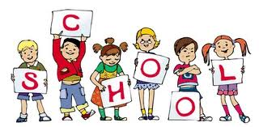](http://www.google.com.au/imgres?q=parent+teacher+clipart&num=10&hl=en&safe=active&biw=1233&bih=941&tbm=isch&tbnid=bZ4234JHwZUZkM:&imgrefurl=http://wgelementarypto.digitalpto.com/2012/08/08/pre-k-1st-day-of-school-has-changed/&imgurl=http://wgelementarypto.digitalpto.com/files/2012/08/school-kids-clipart1_000.gif&w=400&h=197&ei=gyA8UMStH4OCmQWj74DABQ&zoom=1&iact=hc&vpx=613&vpy=60&dur=1841&hovh=157&hovw=320&tx=147&ty=96&sig=117378215908878520347&page=1&tbnh=97&tbnw=197&start=0&ndsp=30&ved=1t:429,r:9,s:0,i:102)

# **[http://t1.gstatic.com/images?q=tbn:ANd9GcQiNDoHbzaNu36Bc9u2wrJT5Q7nLdMxeq53hn-hAuuM3x1lA3h5CA](http://www.google.com.au/imgres?q=school+uniform+clipart&start=413&hl=en&safe=active&biw=1233&bih=941&tbm=isch&tbnid=jJGl2RTAbv5SdM:&imgrefurl=http://shymolecules.blogspot.com/2010_07_01_archive.html&imgurl=http://4.bp.blogspot.com/_qzFYw7JN-yA/TEXUNVHjNzI/AAAAAAAABYA/xWBZFDKUE34/s1600/88430-Royalty-Free-RF-Clipart-Illustration-Of-Three-Diverse-School-Children-Walking-Up-On-An-Arrow.jpg&w=450&h=257&ei=OCg8UPO6Fa_ImAWGi4HgDw&zoom=1&iact=hc&vpx=372&vpy=358&dur=5291&hovh=170&hovw=297&tx=153&ty=82&sig=117378215908878520347&page=11&tbnh=103&tbnw=180&ndsp=42&ved=1t:429,r:30,s:413,i:236)STUDENT ENGAGEMENT POLICY**

Marysville Primary School provides all students with a safe and caring environment where self discipline and individual rights and responsibilities form the basis of student discipline and welfare. Our Student Engagment Policy is based on the premise that discipline is a joint responsibility between the home and the school acknowledges the range of DEECD policies relating to student management and support. These policies include student attendance, homework guidelines, dress code, student welfare and emergency management.

**Principles**

Our school believes that all students are:

* valued, treated with respect, courtesy and kindness
* safe within the school environment and work or play without intimidation, bullying or harassment
* able to develop their individual talents and interests

Teachers have a right to expect that they will be able to teach in an orderly and cooperative environment. Parents have an obligation to support the school in its efforts to maintain a positive teaching and learning environment.

##### Standards /Rules

We believe that all students have a responsibility to:

* contribute to and be involved in learning situations
* obey instructions from school staff
* be thoughtful, respectful and courteous to others
* take care of school, others and their own property
* ensure that they do not disrupt the learning opportunities of other students
* accept and obey school rights, responsibilities and rules

**Consequences**

Breaches of school rules may incur some penalty or action. These penalties or actions will be a logical consequence of the misbehaviour such as:-

* discussion with the offender followed by a warning
* written and /or verbal apology to be signed by the student, teacher, Principal and parent.
* set tasks
* withdrawal of privileges eg; sport, excursions.
* period of detention during recess/lunchtime periods
* 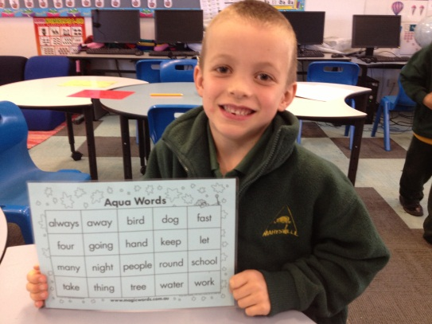contact with parent
* individual behaviour contract
* referral to counselling services
* formation of support groups

**SCHOOL ORGANISATION**

##### SCHOOL COUNCIL

All government schools in Victoria have a School Council. They are legally formed bodies that are given power to set the key directions of a school within centrally provided guidelines. In doing this a School Councils is able to directly influence the quality of education that the school provides to its students.

There are three possible categories of membership.

* A compulsory elected **parent** category. More than one third must be from this category.
* A compulsory elected **Department of Education, Employment & Training employee** category. The Principal of the school is automatically one of these members.
* An optional category is the **community** member category. Its members are co-opted by the decision of the council because of their skills, interests or experiences.

The term of office is for two years. Half the members must retire each year and this creates vacancies for the annual school council elections. Parents on School Council provide an important contribution and have valuable skills that can help shape the direction of the school. Elections are held each year and all parents are invited to stand for election or encourage another person to stand. No special experience is necessary-simply an interest in your child’s school.

**Finance:** Monitors the school’s finances, oversees the preparation of program budgets and makes recommendations regarding financial matters.

**Buildings and Grounds:** Plans and coordinates projects related to school buildings and grounds. Organises working bees.

[](http://www.google.com.au/imgres?q=parent+teacher+clipart&start=190&num=10&hl=en&safe=active&biw=1233&bih=941&tbm=isch&tbnid=HqvQT-6gT7hu_M:&imgrefurl=http://drumfriesns.scoilnet.ie/blog/staff/&imgurl=http://drumfriesns.scoilnet.ie/blog/files/2012/03/clip-art-meeting-081393.jpg&w=400&h=384&ei=wCA8ULmRHMaJmQXsq4GgCw&zoom=1&iact=hc&vpx=485&vpy=328&dur=1915&hovh=220&hovw=229&tx=106&ty=135&sig=117378215908878520347&page=6&tbnh=138&tbnw=144&ndsp=39&ved=1t:429,r:21,s:190,i:72)

##### 

##### JUNIOR SCHOOL COUNCIL

Each year a Junior School Council is formed with students from each room to represent the students at the school. They fulfil an important role in the school, assisting with special meal days and other events throughout the year.

**[](http://www.google.com.au/imgres?q=school+camp+clipart&num=10&hl=en&safe=active&biw=1233&bih=941&tbm=isch&tbnid=dT4_ZRjhZqU1HM:&imgrefurl=http://www.adriveablefeast.com/2011/03/summer-camp-fair.html&imgurl=https://lh3.googleusercontent.com/-j7lKVN70SQ4/TW7B0cdHhEI/AAAAAAAAA9o/Lg1rJXsjOBY/sign_to_camp_clipart_bw.gif&w=512&h=293&ei=xSU8UNvyLeHXmAXUsIEg&zoom=1&iact=hc&vpx=893&vpy=143&dur=2424&hovh=170&hovw=297&tx=150&ty=100&sig=117378215908878520347&page=2&tbnh=101&tbnw=177&start=31&ndsp=42&ved=1t:429,r:13,s:31,i:213)SCHOOL CAMPS & EXCURSIONS**

###### It is expected, though not compulsory, that all students will be involved in these types of activities which provide a balanced curriculum and all parents are urged to support them. Notification will be provided as early as possible in the year so that parents can budget for the costs involved. Lay-by options are also available (see Kylie at the office)

**SCHOOL DATES 2014**

Term 1: 28 January (school teachers start) to 4 April *

Term 2: 22 April to 27 June

Term 3: 14 July to 19 September

Term 4: 6 October to 19 December

**PREP INFORMATION**

**When can I start school?**

Children must be 5 by the 30th April of the year they enter school. *They are not required to start school until they are 6.* The older children are, the more likely they will be able to cope with learning expectations and the demands of schooling in both primary and secondary school. It is important to note however that **age** is not the only thing to consider- parents must consider each child’s own rate of development.

**School Readiness Checklist**

*Experience indicates that the majority of children starting school are able to:*

**Social**

* Play cooperatively with other children
* [](http://www.google.com.au/imgres?q=parent+teacher+clipart&start=269&num=10&hl=en&safe=active&biw=1233&bih=941&tbm=isch&tbnid=a-ZXcOFywDYc0M:&imgrefurl=http://pwes.monticello.schoolfusion.us/modules/cms/pages.phtml?pageid=237677&SID&imgurl=http://pwes.monticello.schoolfusion.us/modules/groups/homepagefiles/cms/2453694/Image/Pinewood/Parent%20Resources/Back%20to%20School%20Clip%20Art%20671.jpg&w=338&h=450&ei=yiE8UPKHHuPUmAW-m4GgDA&zoom=1&iact=hc&vpx=115&vpy=221&dur=1386&hovh=259&hovw=194&tx=111&ty=178&sig=117378215908878520347&page=8&tbnh=146&tbnw=108&ndsp=40&ved=1t:429,r:7,s:269,i:28)Cooperate with adults other than family
* Initiate conversations with others
* Display appropriate behaviours

**Emotional**

* Separate easily from parents
* Express own needs verbally
* Pays attention in a group situation
* Concentrate on a task (5mins.)
* Persevere on a task that they find difficult
* Have confidence in their own ability
* Accept rules
* Display appropriate behaviours

**Physical**

* Go without sleep during the day
* Use toilet unaided
* Wash and dry own hands
* Take own clothing on and off *eg; windcheater, coat, socks, shoes(not necessarily laces)*
* Manage own lunch box and drink

**Fine Motor Skills**

* Draw a recognisable person or object
* Cut with scissors
* Copy recognisable shapes

**Gross Motor Skills**

* [](http://www.google.com.au/imgres?q=parent+teacher+clipart&num=10&hl=en&safe=active&biw=1233&bih=941&tbm=isch&tbnid=iN42PFCs8MYfiM:&imgrefurl=http://exploringsciencewiki.wikidot.com/toc&imgurl=http://exploringsciencewiki.wikidot.com/local--files/toc/hug-club-clip-art-716.jpg&w=1288&h=799&ei=gyA8UMStH4OCmQWj74DABQ&zoom=1&iact=hc&vpx=108&vpy=248&dur=820&hovh=177&hovw=285&tx=125&ty=111&sig=117378215908878520347&page=2&tbnh=114&tbnw=184&start=30&ndsp=37&ved=1t:429,r:7,s:30,i:193)Walk easily along a narrow line
* Skip on alternate feet
* Stand and balance on either foot for 8-10 seconds
* Hop 2-3 metres forward on either foot
* Competent and skilful climbing, sliding and swinging

**Academic Skills**

* Recognise their own name
* Enjoy listening to stories
* Identify basic colours
* Show an interest in print eg; names, signs.
* Recite familiar rhymes or jingles
* Recognise some numerals
* Speak clearly and fluently

**Helping Your child with their Learning**

You, as parents and carers, are the first and one of the most important links in the chain of teaching and learning. Learning starts as soon as children are born. As you teach them to speak and to listen, you are laying the foundations for learning.

Often as parents we worry about how to help children do well at school. Research has shown that giving our children *time* is one of the best things we can do. Children who spend time *with their parents* achieve higher school results.

Children love to spend time with you alone.

Teaching children to organize their time is another way to support them at school.

Help your children establish good habits. *Make sure they put away or hang up things as they walk in the door. Schedule a regular homework time and stick to it.*

A successful morning begins at night. *Before your children go to bed, help them set out everything they’ll need for school-* uniform, lunch, drinks, readers, permission slips.

Establish a regular bedtime*. Children who fall asleep on the couch at 11pm rarely rise or shine at 7:00am.*

Ensure that your child has a good breakfast. *Children learn better on a full stomach. (Cereal, muffins, toast, fruit and yoghurt are all good choices)*

Take a minute to say “I love you” for a better start to each day.

Tips from [www.parent-institute.com/parent/resources/tips/tips.php](http://www.parent-institute.com/parent/resources/tips/tips.php))

##### YOUR CHILD NEEDS TO BRING TO SCHOOL:

1. **A smock for art**.

Protective clothing must be worn when in the art room. An old shirt is suitable, and preferably something your child can put on unaided that will completely cover their school clothes.

1. **Library Bag** Cloth bags for library books are essential to care for our schoolbooks. All prep children receive one at the beginning of the school year from the Department of Education, but this may need to be replaced if misplaced or worn out in later years**.**
2. **A spare change of clothes** for emergency use. This applies particularly to the young children. (This can be kept at school)
3. **Sunsmart hat.**
4. **A water bottle** with a lid.
5. **Class Requirements.** These requirements are purchased by the school for each child using the fees which you are asked to pay.They will be distributed to children during the first week of school.
6. **School Bag** Please ensure that your child’s school bag is not too big or difficult for them to carry. Parent’s Club have school bags available from the office.

##### PARENT TEACHER INTERVIEWS

A close partnership between home and school is encouraged at Marysville Primary School. Our staff are very friendly and can be easily approached if you have any concerns at all or would like to discuss your child’s progress, contact you child’s teacher or the Principal at any time.

Similarly if teachers have a concern we would discuss this with parents as soon as possible. Please, if you have a concern, then approach the school so that something positive can be done.

Reporting children's progress - during Term 1 we conduct ‘meet the teacher’ interviews followed by Mid Year written reports issued in conjunction with ‘parent teacher interviews’.

End of Year written reports are held in conjunction with parent teacher interviews. Student Support Group meetings will be held at mutually agreeable times.

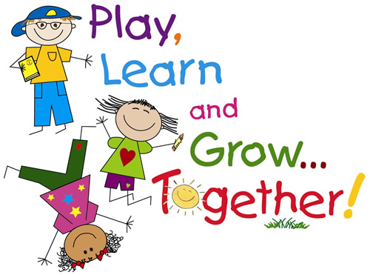

Child6Child6Child6

[](http://www.google.com.au/imgres?q=school+uniform+clipart&start=328&hl=en&safe=active&biw=1233&bih=941&tbm=isch&tbnid=VW-MfCL-_lAEvM:&imgrefurl=http://teacherweb.com/LA/FifthWard/Fussell-TRT/t.aspx&imgurl=http://teacherweb.com/LA/FifthWard/Fussell-TRT/ladybug-clipart.png&w=443&h=289&ei=ICc8UOWDAujLmgWQxIHICQ&zoom=1&iact=hc&vpx=106&vpy=556&dur=3659&hovh=181&hovw=278&tx=160&ty=107&sig=117378215908878520347&page=9&tbnh=114&tbnw=174&ndsp=42&ved=1t:429,r:14,s:328,i:177)

The **Department of Education and Early Childhood Development** has a comprehensive website for parents - <http://www.education.vic.gov.au/school/parents/primary/Pages/default.aspx>

##### HELPING YOUR CHILD TO READ AND WRITE

Learning to read and write starts long before children enter school.

Being able to clearly hear and speak helps us to recognise the sounds words make when we are reading and spelling. Being a good listener ourselves is also important. Speaking and Listening are like manners- they are ‘caught’ rather that ‘taught’. Children copy our habits.

One of the most useful things you can do is to show your children that **you** read and write.

*Read the paper, magazines, shopping catalogues, finding recipes, locating phone numbers, checking the Tattslotto numbers, writing down phone messages, making shopping lists, writing on cards and invitations, making simple maps for friends to find your house* are some examples of activities that many parents do regularly that show children reading and writing in everyday life.

Simple games and activities are also great tools to prepare for reading and writing.

**Read to and with your children every day.**

**All children love to be read to, no matter what age**. Make this a special time, such at bed time. Through stories you share your pleasure in books and help your children become familiar with the language of books. As you read, hold the books so that the children see it too. Encourage them to join in the parts they know by heart, thus building confidence in their abilities as readers.

Reading can be lots of fun.

When your child brings home their first books, share their excitement with them. At first they will ‘read’ by remembering the sentence patterns or looking at the pictures. This is a natural stage in learning to read.

The most important thing is to encourage them to make sense of what they read. If what they read does not make sense, repeat it and ask ‘Does that make sense?’ If they get stuck on a word ask them to have a guess . What do you think would make sense? Encourage their attempts instead of drawing attention to their mistakes.

Make reading time a pleasure- not a chore.

**Enjoy your experience with us at Marysville Primary School.**

**[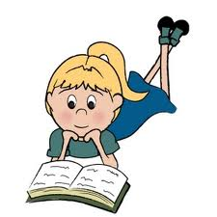](http://www.google.com.au/imgres?q=parent+teacher+clipart&start=149&num=10&hl=en&safe=active&biw=1233&bih=941&tbm=isch&tbnid=0hAKGHfYaBLGwM:&imgrefurl=http://slowburbs.com/2011/08/30/shell-learn-to-read-in-her-own-due-time/&imgurl=http://www.book-clipart.com/free_book_clipart/girl_reading_a_book_while_laying_on_the_floor_0515-1002-0104-0834_SMU.jpg&w=300&h=300&ei=lSA8UMvrKe2YmQXtp4CgAg&zoom=1&iact=hc&vpx=419&vpy=425&dur=1890&hovh=225&hovw=225&tx=103&ty=113&sig=117378215908878520347&page=5&tbnh=138&tbnw=147&ndsp=41&ved=1t:429,r:8,s:149,i:291)Welcome!!**